THIS DEED is made the 16th Day of October One Thousand Nine Hundred and Ninety-seven BETWEEN SINCLAIR GARDENS INVESTMENTS (KENSINGTON) LIMITED whose registered office is situate at PO BOX 65 Bognar Regis in the County of West Sussex ( hereinafter called "the Landlord") of the one part AND ANTHONY JAMES OCCLESHAW of Flat 11 Langham Court Station Approach South Ruislip in the county of Middlesex (hereinafter called “the Tenant") of the other part

WHEREAS:-

1. The Landlord is entitled to the reversion immediately

expectant on the determination of the Lease (hereinafter referred to as "The Lease") short particulars whereof are set out in the schedule hereto

1. Flat 11 LANGHAM COURT STATION APPROACH SOUTH RUISLIP

MIDDX HA4 6RX (hereinafter called "the Property") is now vested in the Tenant for all of the unexpired residue of the said term of years

3] The reversion immediately expectant on the determination of the Lease is now vested in the Landlord

1. The Tenant has requested the Landlord to vary the Lease which the Landlord has agreed to do in consideration of the sum of

£7250.00(Seven Thousand Two hundred and Fifty pounds) (the receipt whereof the Landlord hereby acknowledges) and subject to the terms and in the manner hereinafter appearing

NOW THIS DEED IS WITNESSETH AS FOLLOWS:-

The Lease of the flat henceforth shall be read and construed and take effect as if:-

* 1. On page 1 of the Lease in line twenty-nine the words "NINETY NINE YEARS" sha.11 be removed and the words "ONE HUNDRED AND THIRTY NINE YEARS" shall be entered in their stead
  2. On page 1 of the Lease in line thirty-one after the words "rent of” and before the words in the thirty-fifth line “2. THE LESSEE HEREBY COVENANTS” all words shall be removed and the words "£170 (One Hundred and Seventy Pounds) per annum for the period to 29th September 2017 on which date there shall be a review of the annual rent to 1/200th of the open market value and thereafter the rent shall be reviewed on every 20th anniversary of the preceeding rent review time shall not be of the essence at l/200th of the open market value at the time of the review all such rents due hereunder shall be payable in advance on the 29th September in each year without deduction legal or equitable setoff whatsoever a proportionate part of the rent to be paid on the execution hereof calculated to the 29th September next.

IN THE EVENT the parties to the rent review fail to agree the open market value the matter shall be referred to a Chartered Surveyor experienced in valuations to be appointed by the Landlord who shall determin the open market value by reference to what might be paid for the leasehold in the open market for premises in good condition without encumbrances

such value negotiated between a willing seller and a willing buyer” shall be entered in their stead

We certify that this is  
A true copy of the original  
Allsop Dum LLP

**H.M. LAND REGISTRY LEASEHOLD TITLE REGJSTERED**

**TlTLE** NUMBER: AGL60759

2 Midcroft Ruislip

Middlesex **HA4 BES**

* 1. On page 4 of the Lease following the last line of clause 2

(12) there shall be entered a sub-clause numbered 2 (12)(A] as follows:-

2 (12)[A] Upon any transaction or disposition to which the Lessee is a party to procure that the person becoming or contracting to become (as a result of such transaction or disposition) the owner of the demised premises enter into a Deed of Covenant with the Landlord to observe and perform all covenants by the Lessee with the Landlord in the Lease. The costs and expenses of the Landlord in entering into the covenant shall be borne by the new owners

* 1. On page 4 of the Lease within clause 2.(13) in line twelve of the clause the words "a fee of one guinea" shall be removed and the words "a reasonable fee" shall be entered in their stead
  2. On page 5 of the Lease following the last line of clause 2.( 21) shal1 be entered a further clause numbered clause 2.(22) as follows:-

2.(22) To pay interest at the rate of 4% above the National Westminster Bank Plc base lending rate or such other bank lending rate to be determined by the the Landlord on any monies due and payable under the Lease or this Deed should same remain unpaid for 21 days from the due date such interest to be calculated daily from the date for payment to the date on which payment is actually made

6) On page 5 of the Lease following the last line of clause 2.( 22) expressed a.bove there slta.11 be entered a further clause numbered clause 2.(23) as follo s:-

2.(23) To pay all proper and reasonable costs charges and expenses to include legal costs of whatsoever kind incurred by the Landlord in relation to the enforcement of the covenants contained within the Lease and this deed to include reasonable remuneration to cover the Landlords time and/or the time of any employee of the Landlord or any appointed agent or employee of such agent appointed by the Landlord engaged in the aforesaid

1. *Save* as modified the lease shal 1 continue in full force and effect in all respects
2. In this Deed words importing the singular shall include the plural and the masculine shall include the feminine and vice-versa
3. 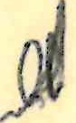IT IS HEREBY CERTIFIED that the transaction hereby effected does not form part of a larger transaction or series of transactions in respect of which the amount or value or the aggregate amount or value of the consideration other than the rent exceeds sixty thousand pounds 1

THE SCHEDULE Jll}fore referred to

**i1** .

DA'l'E OF THE LEASES: .7,8'th January 1958

PARTIES:

DAVIS CONTRACTORS LIMITED

RAYMOND LAKE

FLATS & ESTATES MANAGEMENTS LIMITED.

DESCRIPTION OF THE PROPERTY:

Flat 11

TERM:

ANNUAL RENT:

LANGHAM COURT STATION APPROACH SOUTH RUISLIP MIDDX HA4 6RX

99 years

El0.00

IN WITNESS whereof the Landlord has hereunto affixed its Common Seal the day and year first above written

The Common Seal of SINCLAIR GARDENS TNVESTMENTS (KENSINGTON) )

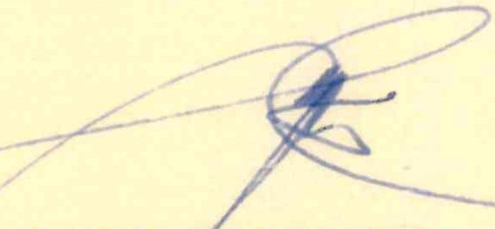

g

LIMITED was hereto affixed in the) presence of:- )

Director

Secretary SIGNED AND DELIVERED by the

above named Tenant:-

*(Jl*?  *A .* _

*--l*--*-*-*-*- *-*

in the presence of:­ address:-

-

) -------z._2:::::-);, ---------

*r Vcj*

.s

TU *t& 0111'-+*

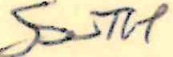*f-.U1(L-/*

*fY)1DiJ><*

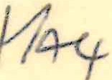

Dale:-

*·(--*

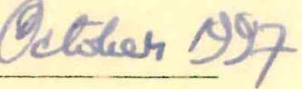Bct1wc11

Sincl;1ir ( ;,1rdcns I nvc'-lmc nls (Kcnsingl1H1) Ltd

,inc.I

/\nthony James<kclcsham

DEED uf VARIATION

in rcsrect of

Fial 11

LANC;HAM COURT STATION APPl<.OACH SOUTH RUISLIP Mll)OX H/\4 (,RX